LAB 26

**Lab1: Write a Pandas program to create a dataframe from a dictionary and display it.** Sample data:

score={'Math':[78,85,96,80,86], 'English':[84,94,89,83,86],'Hindi':[86,97,96,72,83]} **Output:**

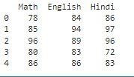

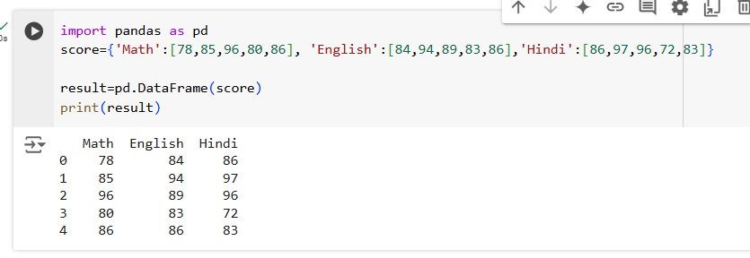

**Lab2: Write a Pandas program to create and display a DataFrame from a specified dictionary data which has the index labels.**

**Sample Python dictionary data and list labels:**

exam_data = {'name': ['Anastasia', 'Dima', 'Katherine', 'James', 'Emily',

'Michael', 'Matthew', 'Laura', 'Kevin', 'Jonas'],

'score': [12.5, 9, 16.5, np.nan, 9, 20, 14.5, np.nan, 8, 19],

'attempts': [1, 3, 2, 3, 2, 3, 1, 1, 2, 1],

'qualify': ['yes', 'no', 'yes', 'no', 'no', 'yes', 'yes', 'no', 'no', 'yes']}

**Output:**

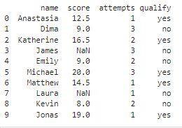

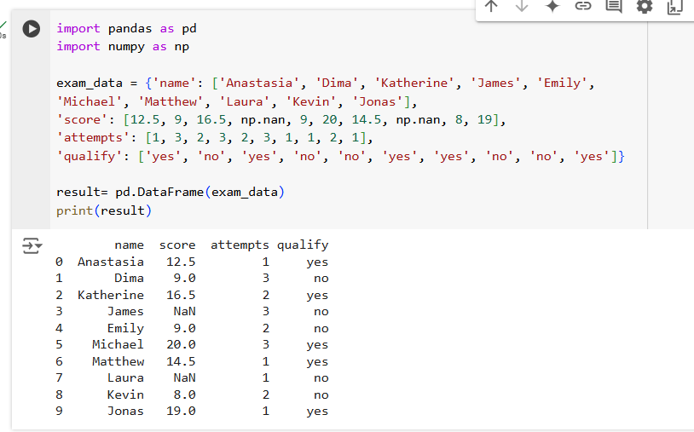

**Lab3: Write a Pandas program to get the first 3 rows of a given DataFrame.**

***Sample DataFrame*:**

exam_data = {'name': ['Anastasia', 'Dima', 'Katherine', 'James', 'Emily',

'Michael', 'Matthew', 'Laura', 'Kevin', 'Jonas'],

'score': [12.5, 9, 16.5, np.nan, 9, 20, 14.5, np.nan, 8, 19],

'attempts': [1, 3, 2, 3, 2, 3, 1, 1, 2, 1],

'qualify': ['yes', 'no', 'yes', 'no', 'no', 'yes', 'yes', 'no', 'no', 'yes']}

**Output:**

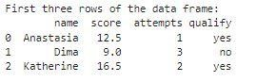

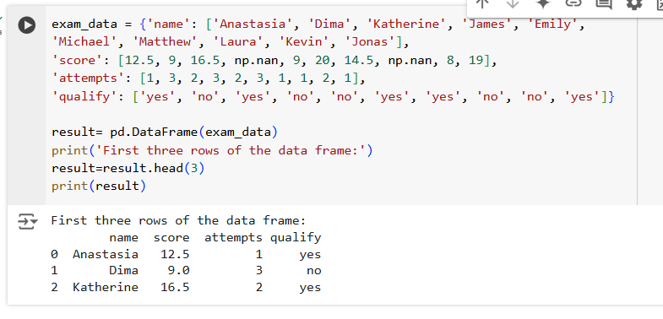

**Lab4: Write a Pandas program to select the 'name' and 'score' columns from the following DataFrame.**

**Sample Python dictionary data and list labels:**

exam_data = {'name': ['Anastasia', 'Dima', 'Katherine', 'James', 'Emily',

'Michael', 'Matthew', 'Laura', 'Kevin', 'Jonas'],

'score': [12.5, 9, 16.5, np.nan, 9, 20, 14.5, np.nan, 8, 19],

'attempts': [1, 3, 2, 3, 2, 3, 1, 1, 2, 1],

'qualify': ['yes', 'no', 'yes', 'no', 'no', 'yes', 'yes', 'no', 'no', 'yes']}

**Output:**

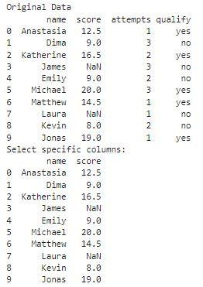

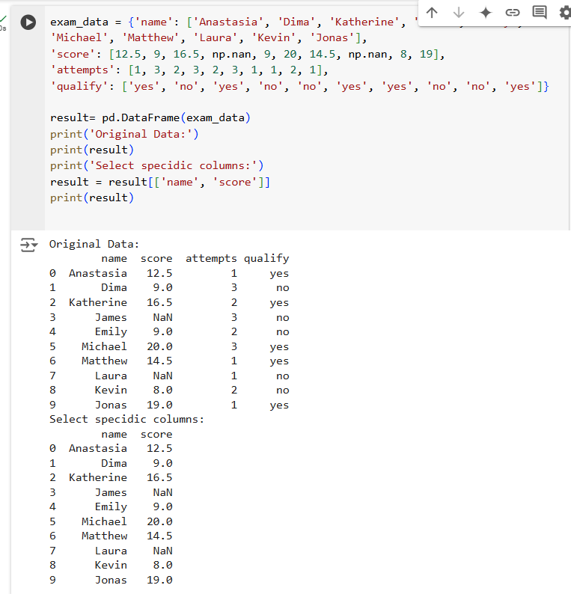

**ChatGPT Exercise**

**Using ChatGPT generate the python code to solve the same problem**

**Scenario: Analyzing Sales Data**

Suppose you work for a retail company, and you have a dummy dataset containing sales data for the past year. The data includes information such as customer names, product names, sales quantities, prices, and dates. You want to perform various data analysis tasks like Total revenue for the year,Average revenue per sale,Best-selling product,Date with the highest total revenue also wants to generate product and total sales wise barchart using Pandas DataFrames.

Further, you need to get some inference out of the chart.

Create a ChatGPT prompt to generate the code for this scenario. Based on the code generated, ask ChatGPT to give the conclusion/inference.

Note. You can provide the data to ChatGPT in the form of a list or dictionary or ask it to use sample data.

